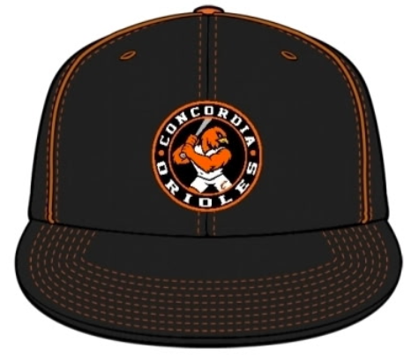
CHS Baseball Cap Order Form

Cost: $ 26.00
Order by: November 13th – must pay at the time of order
Make Checks Payable to Concordia R-2 Schools or cash
(one form per hat please)
Circle Size:
XS/S (6 3/8 – 6 3/4)
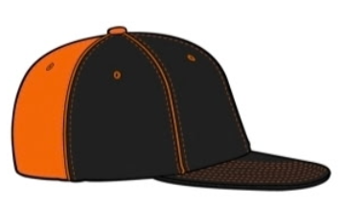
S/M (6 3/4- 7 1/8)
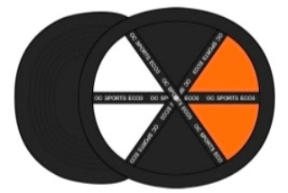
M/L (7-7 3/8)
L/XL (7 1/4 - 7 5/8)
XL/XXL (7 ½ - 8)

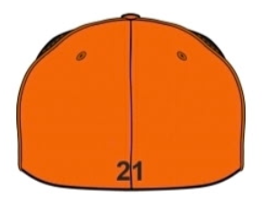
Player number:
(optional for fans or parents)
______________
Initials or name on Back of hat ($5.00 extra)
______________
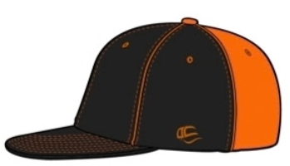
Customer Name:
___________________________
Phone Number:
___________________________

